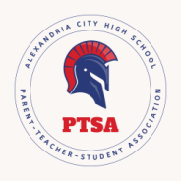

Alexandria City High School PTSA
Reimbursement/Check Request Voucher
(2026-2027)

Date:
Name:
Description of Expense:
Check Payable to:
Amount:
Date Check Needed (if applicable): ________________________________________________________________
Delivery Method of Check: □ PTSA Meeting □ Mailed
US Mail Address: _________________________________________________________________________________
Signature: _______________________________________________________________________________________

Please deliver this form with purchase order, invoice, bill or receipt to the PTSA Treasurer. You may drop email/text to:

Amy Gareis
Treasurer@achsptsa.org
703-851-4053

- Reimbursement requests must be submitted within 30 days of the expense.
- PTSA will only reimburse expenses that are in the budget, approved by the President in advance, or approved by a General Membership vote in advance.
........................................................................................................................................

Treasurer’s Use Only

PTSA Check Number: _____________________________________________________________________________
Date of Check: ___________________________________________________________________________________
Expense Category: _______________________________________________________________________________

